**Harris Academy**

**Reading Recommendations ReRecommendations**

** Dystopian**

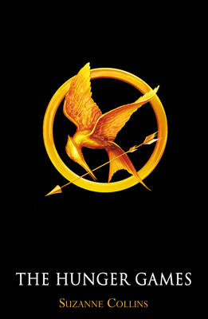 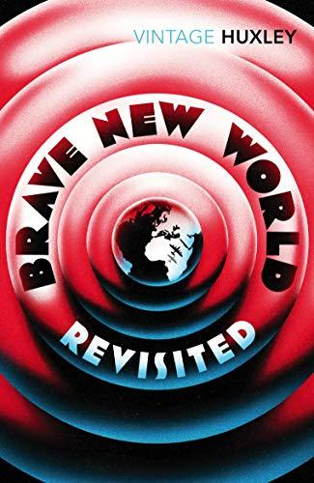 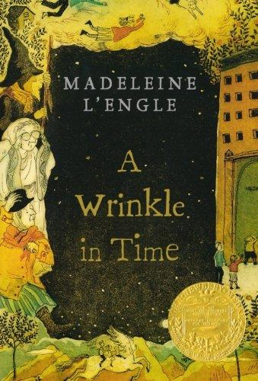 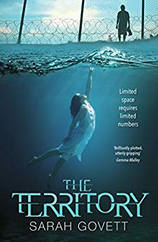

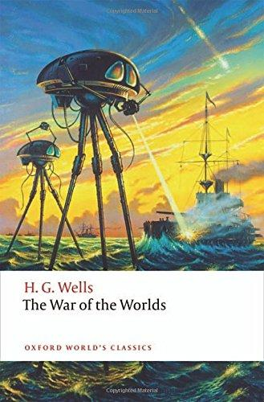 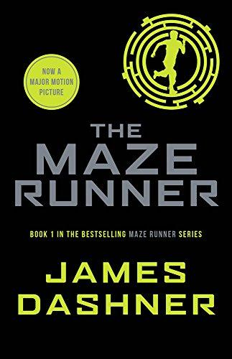  [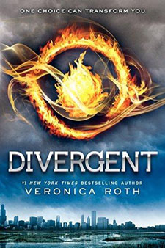](https://www.abebooks.com/products/isbn/9780062387240/?cm_sp=merch-_-product-_-PLP)

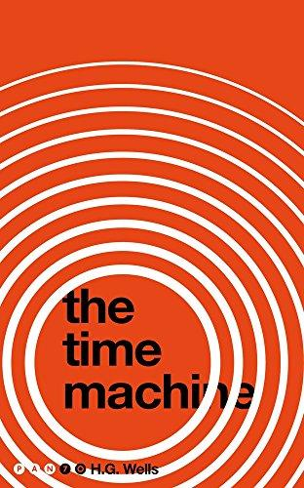 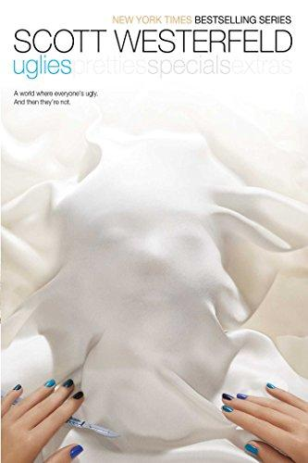 [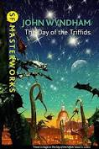](https://www.google.com/aclk?sa=L&ai=DChcSEwjXufbzzIrmAhWIs-0KHWx2CREYABADGgJkZw&sig=AOD64_2lW0ys4woxXdr2zsMLjFVw1Nvs7w&ctype=5&rct=j&q=&ved=2ahUKEwjrre_zzIrmAhXeUBUIHT8VA3EQ9aACegQIFBBc&adurl=) 