Books of the Month

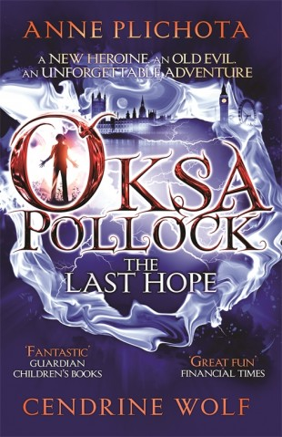
A new heroine. An old evil. An unforgettable adventure.
Oksa Pollock is just a normal thirteen-year-old girl, moving with her family from her home in Paris to a new life in London-new friends, a new school and new adventures. But bizarre things start happening around Oksa. Suddenly, she finds she can produce fire from her hands, move objects with her mind, and even fly. As Oksa experiments with her wonderful new powers, her family notice, and an amazing truth is revealed... Along with her best friend, Gus, her loving, powerful grandmother, her wicked new Physics teacher, her mysterious uncles and a whole host of fantastical creatures, Oksa will be thrown into a wilder adventure than she could ever have imagined.And Oksa knows she must triumph over her enemies. A whole world is counting on her. The Last Hope is the first book in the phenomenal Oksa Pollock series, followed by The Forest of Lost Souls. The Heart of Two Worlds, the third book in the series, is coming soon.

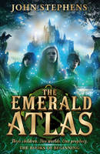
They were taken from their beds one frozen night, when the world was covered in snow. The silhouette of a tall, thin man has haunted Kate ever since.
Ten years on, Kate, Michael and Emma have grown up in a string of miserable orphanages, and all memories of their parents have faded to a blur. Arriving at Cambridge Falls, the children quickly realise there is something different about this place - and Kate feels sure she has seen the dark, crooked house before.
As they explore, they discover an old, empty leather book. The moment they touch it, an ancient magical prophecy is set irrevocably in motion, and the children are thrown into a dangerous alternate reality of dark enchantments and terrifying monsters. Only they can prevent the terrible event that will ruin Cambridge Falls - and stop the world from falling into complete devastation.

