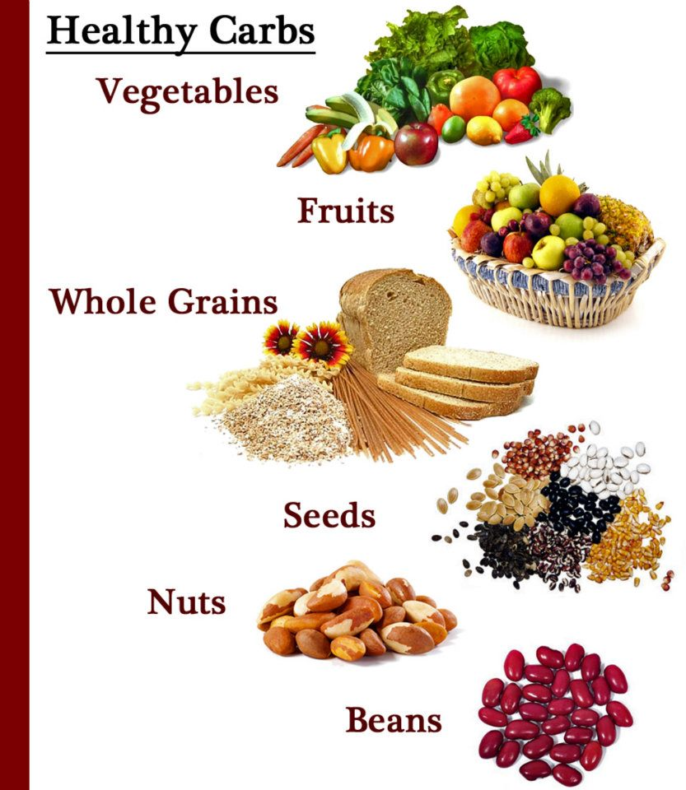

Harris Academy
Home Economics

S2 Recipe Book
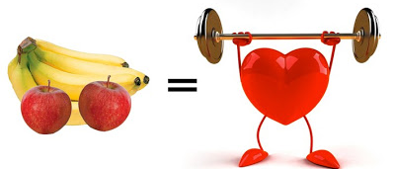
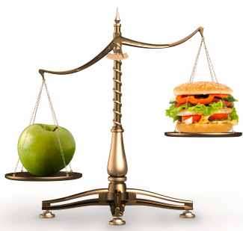

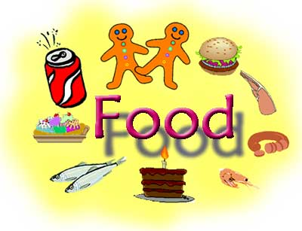
Curriculum for Excellence
Significant Aspects for Learning
Recipes (Linked to Significant Aspects of Learning)
Central to the progression of learning is the development of practical, organisational and problem solving skills
Nutrition
- Chicken fajitas
- Potato Wedges (paired task)
- Fruit Crumble (2 lessons)
Pan Fried Vegetable Couscous (teacher observation)
- Sweet & Spicy Vegetarian Stir Fry

Developing Healthy Choices
Linking food & health
Preparing food appropriate to learning
Nutritional Needs
Varied diet
Individual needs

Food & textile Technology
- Spaghetti Carbonara
- Mini Mandarin cheesecake
- Butterfly cakes x 2 lessons
(Peer assessment)
- Gingerbread Men (2 lessons)
- Eve’s Pudding (paired task)

Food & Textile Technology
Creativity, Design, Dexterity
Developing appropriate items
The Food Experience
Preparing food appropriate to learning

The Food Experience
Preparing food appropriate to learning
Keeping Safe & Hygienic
Preparing food safely & hygienically
Developing Healthy Choices
Linking food & health
Preparing food appropriate to learning
Nutritional Needs
Varied diet
Individual needs

Consumerism
- Jam Sponge Pudding
- Cereal Bars (teacher observation)
- Sausage Rolls
- Quick Choc Chip Cookies
- Hearty Minestrone Soup (2 Lessons)
- Chocolate Truffles

Keeping Safe & Hygienic
Principles of food safety & hygiene
Minimising risk
Preparing food safely & hygienically
The Food Experience
Preparing food appropriate to learning

Globetrotters
- Pizza (2 lessons)
- Quesadillas
- Chow Mein
(Teacher observation)
- Samosa (2 lessons)
- Tiffin

Nutrition: HWB 29 -32 Safe & Hygienic Practices HWB 33 Food & the Consumer HWB 34 – 37 Food & Textiles TCH 10 -11

Chicken Fajitas
Equipment
Frying pan
Pan stand
Red chopping board
White chopping board
Vegetable knife
Wooden spoon
Plate
Round bladed knife
Measuring spoons

Success Criteria
- I can identify the high risk foods used in this recipe and their storage

- I can identify the main nutrient of this recipe and give at least one reason why the body needs it
Learning Intentions
- I will be revisiting food hygiene and safety rules learned in 1st year
- I will be developing my knowledge of cooking foods that contain nutrients needed for growth and development
Ingredients
1 Flour Tortilla
Piece Onion
Piece Red Pepper
Piece Green Pepper
Portion cooked chicken
15ml Salsa
15ml Sour Cream
10ml Oil

Method
- Wash and pat dry the peppers then de-seed and cut into thin strips.
- Thinly slice the onion.
- Cut chicken into smaller pieces and set aside.
- Heat oil in frying pan and add all the vegetables. Pan fry for two minutes
- Add the cut chicken and heat through – approximately 3 minutes.
- Spread the salsa and sour cream on the tortilla.
- Spoon the chicken and vegetables onto the tortilla.
- Carefully fold the sides of the tortilla to prevent the filling falling out and roll up.

Potato Wedges & Salsa (Paired Activity)
Success Criteria
- I am confident using a bender and demonstrated working safely

- I worked safely and hygienically when preparing this recipe and can suggest reasons why this is important
Learning Intentions
- I will be revisiting how to use a blender safely

- I will be demonstrating safe hygiene practices when preparing this recipe with my partner

Equipment
White chopping board
Vegetable knife
Measuring Jug
Baking tray
Parchment paper
Hand blender

Salsa
100g Plum Tomatoes
2.5ml Balsamic Vinegar
5ml Olive Oil
2.5ml Chilli Powder
Sprig Parsley
Piece onion
Piece red Pepper
Piece cucumber
1 Garlic Clove

Ingredients
Two Large Potatoes
15ml Olive Oil

Oven Temperature 220°C/Gas 8
Method
- Place parchment paper onto baking tray and set aside.
- Wash and pat dry the potatoes. Cut each on into around 8-10 wedges.
- Place wedges onto parchment paper and drizzle with oil. Rub the oil into the wedges. Alternatively place the wedges in a bowl with the oil and rub together.
- Bake in the oven for approximately 30 – 35 minutes. Test for readiness.
- Add plum tomatoes, balsamic vinegar, olive oil chilli powder and seasoning into measuring jug
- Wash, pat dry and dice the pepper and cucumber then roughly chop garlic and parsley. Add all ingredients to measuring jug
- Place the hand blender into measuring jug and switch on. Blend then check consistency and continue if necessary.
- Divide mixture evenly between two containers.
- Remove wedges from oven. Divide between two containers.

Fruit Crumble
Equipment
White chopping board
Vegetable knife
Peeler
Mixing bowl
Tablespoon
Plate
Round bladed knife
Baking tray

Success Criteria
- I carried out my rubbing in task and created a nice crumble mix that was well incorporated

- I demonstrated how to core and slice my apple to the best of my ability

Learning Intentions
- I will be demonstrating my ability to make a crumble mix using the rubbing in method

- I will be further developing my knife skills when coring and slicing an apple
Ingredients
75g Plain Flour
25g Wholemeal Flour
50g Margarine
50g Sugar
1 small cooking apple
Tablespoon mixed berries

Oven Temperature 200C/Gas 6

Method
- Weigh the flour into a large mixing bowl and collect sugar onto a plate.
- Place margarine in bowl with flour and cut into small pieces.
- Rub margarine into flour until mixture looks like breadcrumbs
- Wash, peel and core the apple. Very thinly slice and place in the bottom of an oven proof dish
- Add the mixed berries then sprinkle with ½ the sugar.
- Stir the remaining sugar into the flour mixture and then sprinkle mixture evenly over fruit.
- Place on a baking tray and bake for approximately 20 minutes until golden in colour and shrinking from the sides.

Pan Fried Vegetable Couscous with Feta Cheese
Success Criteria
- I prepared my vegetables correctly and as a result am becoming more confident in my knife skills

- I can state the key nutrients in this recipe and their functions

Learning Intentions
- I will be further strengthening my knife skills by preparing a selection of vegetables correctly

- I will be continuing to explore key nutrients in recipes and their functions
Ingredients
Equipment
White chopping board
Vegetable knife
Mixing bowl
Measuring jug
Measuring spoons
Fork
Frying pan
Pan Stand

50g. Couscous
15ml Olive Oil
75ml vegetable stock
Piece yellow pepper
Piece courgette
¼ red onion
1 mushroom
1.5ml garlic powder
25g Feta Cheese
Basil leaves

Method
- Measure the vegetable stock into a jug then pour in the couscous. Stir then set aside to allow the couscous to absorb the stock.
- Wash and cut the pepper and courgette into 1cm pieces.
- Cut the red onion into similar sized chunks.
- Clean the mushroom and cut in half. Slice into even pieces.
- Heat the oil in the frying pan, add the garlic powder and all the vegetables and gently sweat (lid on) for 5 minutes until softened.
- Remove the vegetables from the heat and place in the mixing bowl.
- Cut feta cheese into cubes and tear basil leaves and place into the mixing bowl.
- Fork the couscous and add to the mixing bowl.
- Carefully fold all ingredients together and place into a container.

Sweet and Spicy Vegetarian Stir Fry
Success Criteria
- I confidently demonstrated each cookery process safely and without support
- Through discussion about health in theory lessons I was able to identify the vegetarian substitute in this recipe

Equipment
Wok/non-stick frying pan
Large pan (between 2)
Pan stand
White chopping board
Vegetable knife
Measuring spoons
Fork
Colander

Learning Intentions
- I will be expanding my knowledge of cookery processes by revisiting stir frying & boiling
- I will be continuing to develop my understanding of using vegetarian options in cooking

Ingredients
Piece onion
Piece pepper
Piece carrot
Piece Quorn fillet
15ml oil
1.25ml chilli powder (or 2.5ml for spicy)
15ml honey
5ml soy sauce
Portion noodles

Method
- Half fill a pan with water and bring to the boil.
- Add the noodles and re-boil. Cook for two minutes then remove from heat, stir and drain. Set aside till needed.
- Wash and pat dry the pepper and carrot. Cut into thin strips
- Thinly slice the onion.
- Cut the Quorn into thin strips.
- Heat the oil in the wok and add the onion, Quorn and chilli powder.
- Stir fry for 2 minutes.
- Add the pepper and carrot and stir fry a further 2 minutes.
- Add the honey and noodles. Stir fry a further 2 minutes.
- Add the soy sauce and stir through.
- Remove from the heat and serve.

Spaghetti Carbonara
Learning Intentions
- I will be able to confidently identify the high risk food in this recipe

- I will confidently demonstrate good food hygiene skills when preparing this dish

Success Criteria
- I confidently identified the high risk food in this recipe and can explain why it is high risk

- I successfully demonstrated good food hygiene practices when preparing this dish

Equipment
Large pan (between 2)
Pan stand
Red chopping board
White chopping board
Vegetable knife
Food scissors
Garlic crushers
Frying pan
Wooden spoon
Colander

Ingredients
50g spaghetti
½ rasher bacon
¼ onion
1 clove garlic
50g cream cheese
15ml oil

Method
- ½ fill a pan with water and bring to the boil.
- Once boiling, add the spaghetti, return to the boil.
- Cook till al dente then drain.
- Finely chop the onion and crush the garlic.
- Remove the fat and cut the bacon into strips.
- Heat the oil in a frying pan and add the onion, garlic and bacon.
- Gently fry until the bacon is cooked.
- Remove from the heat and stir in the cream cheese.
- Add the drained pasta and return to the heat.
- Heat through, coating the pasta with the sauce then serve.

Mini Mandarin Cheesecakes (Paired Activity)
Success Criteria
- I confidently melted the butter without boiling it
I assembled my cheesecake to the best of my ability -
- the base was firm and supported the layers
- I need to practice more as the layers were not distinct

Learning Intentions
- I will be continuing to enhance my food preparation skills – melting

- I will be revisiting my ability to assemble my product - layering
Equipment - base
2 circular moulds
Rolling pin
Mixing bowl
Small pan & pan stand
Wooden spoon
Tablespoon
Baking tray
Greaseproof paper

Equipment - topping
Wooden spoon
Tablespoon
Electric Mixer
Small bowl
Spatula
Plate
Round bladed knife

Ingredients
25g butter
50g digestive biscuits
75g tinned mandarins
50g low fat cream cheese
50mls fresh double cream
10g icing sugar

Method
- Place the greaseproof paper and moulds onto a baking tray.
- Crush the biscuits and melt the margarine then mix together.
- Divide the biscuit mix between the two moulds and press down to an even thickness using a metal spoon. Place in the fridge and allow to firm.
- Set aside two mandarins and cut the remaining segments. Pat dry slightly to remove excess juice.
- In a small bowl gently beat the icing sugar and cream cheese. Do not over beat as the cheese will become too thin.
- Whisk the cream into soft peaks.
- Add the whipped cream and mandarins to the soft cheese and carefully fold together.
- Spoon on top of the biscuit base and top with a mandarin segment. Allow to set in the fridge.
- Carefully remove from the moulds and serve.

Butterfly Cakes
Success Criteria
- I identified safety issues when using an electric mixer and used it properly
- I deposited my mixture as evenly as I could and am happy with the end result
- I created the wings for my butterfly cakes and I did this well
Equipment
Mixing bowl
Electric mixer
Sieve
Metal spoon
Round bladed knife
Cup
Bun tin
6 cupcake cases

Learning Intentions
- I will be demonstrating confidence when using an electric mixer
- I will demonstrate how to deposit my mixture evenly to create even sized cakes
- I will be learning how to create the wings for my butterfly cakes

Ingredients
50g SR flour
5ml baking powder
50g Caster sugar
50 margarine
1 egg
5ml vanilla essence
Spoonful butter icing

Oven Temperature 180°C/Gas 4

Method
- Weigh sugar into a bowl and sieve in the flour and baking powder. Add the margarine.
- Beat the egg in a cup and add to the bowl along with the vanilla essence.
- Using an electric mixer, combine all the ingredients together until light and creamy. Check consistency and adjust if necessary.
- Evenly deposit the mixture between the cupcake cases ensuring no spillages.
- Bake for approximately 15 minutes then remove and cool on a cooling wire.
- Cut the tops off the cupcakes and fill with buttercream.
- Cut the leftover tops in half and set into the buttercream to look like wings. Dust with icing sugar.

Giant Gingerbread Man (Paired Activity)
Learning Intentions
- I will be learning to use a template to create my gingerbread man
- I will be revisiting techniques on how to decorate sweet treats using sweet ingredients
Decoration
Small bag royal icing
Small piece sugar paste
Selection sweets
Success Criteria
- After watching a demonstration I created the shape of my gingerbread man by carefully cutting round a template
- I used a combination of icing and sweets to create my design and I am happy with the end result

Ingredients
Equipment
Food processor
Sieve
Plate
Metal spoon
Round bladed knife
Cup
Measuring spoons
Rolling pin
Template
Baking tray

350g plain flour
5ml bicarbonate of soda
2x5ml ground ginger
5ml ground cinnamon
125g margarine
175g sugar
1 egg
4x15ml golden syrup

Oven Temperature 180°C/Gas 4

Method
- Sieve flour, spices and bicarbonate of soda into the bowl of the food processor. Add butter and mix until it looks like fine breadcrumbs.
- Add sugar and mix gently.
- Lightly beat egg and syrup together then add to the processor and mix until it forms a dough.
- Wrap in cling film and chill for approximately 15 minutes.
- Lightly flour the work surface and roll out the dough to an even 1cm thickness.
- Using the template and knife, cut out the gingerbread man.
- Carefully transfer to a baking tray and bake for around 15 minutes until golden brown.
- Allow to cool slightly on the baking tray then remove onto a wire rack.
- Decorate with icing and sweets.

Jam Sponge Pudding (Peer Evaluation)
Success Criteria
- I have worked independently to make a steamed pudding and enhanced my ability to use different cookery process

- I can identify and explain at least two hazards of microwave cooking

Learning Intentions
- I will be further developing my knowledge of cookery processes by revisiting using a microwave to make a tasty dessert
- I will be reviewing my understanding of safe cooking practices when using a microwave

Equipment
Mixing bowl
Electric whisk
Cup
Fork
Metal spoon
Spatula
Small plastic bowl
Piece greaseproof paper

Ingredients
50g SR flour
50g caster sugar
50g margarine
5ml vanilla extract
1 egg
2x15ml jam

Method
- Collect the jam and soften it. Spoon into the bottom of the small bowl.
- Weigh sugar into the mixing bowl and sieve in the flour.
- Add the margarine.
- Beat the egg in a cup and add to the bowl along with the vanilla essence.
- Using an electric mixer, combine all the ingredients together until light and creamy. Check consistency and adjust if necessary.
- Evenly deposit the mixture on top of the jam ensuring that all the jam has been covered.
- Cover the bowl with a piece of greaseproof paper and microwave on full power for 2-3 minutes.
- Remove and allow to cool slightly in the bowl.

Fruity Cereal Bars
Success Criteria
- I confidently demonstrated how to melt ingredients and combine them
- I followed instructions and can now press and smooth ingredients into a tray to make a simple tray bake
Learning Intentions
- I will be reinforcing my ability to melt ingredients and combine them together

- I will be learning to press and smooth ingredients into a tray to make a tray bake

Ingredients
Equipment
Small pan
Mixing bowl
Measuring spoons
Wooden spoon
Metal spoon
Foil flan case

50g margarine
25g soft brown sugar
2 x 15ml golden syrup
75g rolled oats
25g rice crispies
50g mixed fruit

Method
- Preheat the oven to 180°C/Gas 4
- Lightly grease a foil flan case
- Collect all the dry ingredients into a mixing bowl.
- In a small pan, add the margarine, sugar and syrup.
- Melt on a medium heat, stirring to combine all the ingredients.
- Once combined and completely melted remove from the heat and add in the dry ingredients.
- Mix well to coat all the cereal and fruit
- Spoon the mixture into the prepared tin and smooth with the back of a metal spoon.
- Bake for approximately 20 minutes or until golden around the edges.
- Cool completely in the tin before removing.
- Cut into even sized pieces and store appropriately.

Large Sausage Rolls
Success Criteria
- I demonstrated how to roll pastry to the correct shape and size and have improved the technique
- I considered the knowledge gained over the year to ensure I prepared and cooked my food safely

Equipment
Baking tray (between 2)
Red chopping board
White chopping board
Fork
Rolling pin
Food scissors
Vegetable knife
Mixing bowl
Cup (between 2)
Pastry brush (between 2)

Ingredients
Learning Intentions
- I will be further developing my ability to roll out pastry evenly
- I will be reinforcing my knowledge of food safety and its importance when cooking with raw meat
Small block ready-made puff pastry
1 portion sausage meat
Piece of onion
Pinch mixed herbs
Egg Wash to Glaze
Vegetarian Option
Piece of onion
50g Grated Cheese

Oven Temperature 190°C/ Gas 7

Method
- Lightly flour a baking tray and set aside.
- Roll out pastry to the length of the rolling pin (rectangle).
- Finely dice the onion and place in a mixing bowl along with the sausage meat and herbs then mash together with a fork to combine.
- Sprinkle some flour onto the red board and roll out the sausage and place on the pastry
- Place the rolled out sausage down the middle of the pastry.
- Dampen along one of the long edges of the rolled out pastry.
- Fold the pastry over to cover the sausages roll to neaten.
- Cut into 2 equal pieces, using a clean, sharp knife.
- Place onto the baking tray and use scissors to snip tops and make a pattern. Glaze with the egg wash and bake until golden brown.
- Test for readiness then cool and store appropriately.

Simple Chocolate Chip Cookies
Success Criteria
- I can confidently demonstrate the creaming method to produce a light and fluffy mixture
- I produced even sized cookies by portioning the mixture correctly and am happy with the results
Learning Intentions
- I will be reinforcing my ability to cream ingredients together

- I will be reinforcing my ability to divide a mixture and portion it evenly to ensure an even bake

Equipment
Mixing bowl
Plate
Wooden spoon
Measuring spoons
Baking Tray
Cooling Wire

Ingredients
50g soft margarine
50g soft brown sugar
7.5ml golden syrup
75g SR flour
15ml chocolate chips

Oven temperature 160°C/Gas 3

Method
- Lightly flour a baking tray and set aside.
- Cream the butter and sugar together until soft and creamy.
- Add the syrup and ½ the flour. Mix together.
- Add in the remaining flour and chocolate chips. Mix well to evenly distribute the chocolate chips.
- Divide the mixture into 6 even sized balls.
- Place well apart on the baking sheets - do not flatten them.
- Bake for about 10 minutes until pale and golden in colour.
- Leave to cool on the tray for a few minutes and then remove onto a wire to cool completely.

Hearty Minestrone Soup
Success Criteria
-I confidently demonstrated my food preparation techniques and have learned the terms for vegetable cuts
- I can explain the difference between boiling and simmering and can control these processes during cooking.

Learning Intentions
- I will be expanding my knowledge of food preparation techniques by learning terms for cuts of vegetables

- I will be demonstrating confidence in my knowledge of cookery processes when preparing this recipe

Ingredients
Lesson 2
½ rasher bacon (optional)
15ml oil
300ml vegetable stock 50ml chopped tomatoes
15ml tomato puree
1.25ml garlic powder
2.5ml mixed herbs
5 strands spaghetti

Equipment
White chopping board
Vegetable knife
Peeler
Large pan & lid
Jug
Measuring spoons
Wooden spoon

Lesson 1
¼ onion
Piece of carrot
Piece of celery
Piece cabbage leaf
Pasta/spaghetti

Method
- Wash the carrot, celery and cabbage leaf.
- Prepare vegetables as follows –
  - Onion – finely diced
  - Carrot – peel and macedoine
  - Celery – sliced (paysane)
  - Cabbage – chiffonade
___________________________________________

- Collect stock, chopped tomatoes, puree, garlic and mixed herbs in a jug.
- Trim the fat and cut the bacon into small pieces.
- Heat the oil in a pan, add the onions and bacon and fry for 3 minutes.
- Add the carrot and cook for a further 2 minutes.
- Add the celery, cabbage and stock and bring to the boil – reduce to a simmer. Cover and cook for 10 minutes, stirring occasionally.
- Add a handful of pasta or break up the spaghetti into small pieces and add to the pan. Cook a further 10 minutes.
- Remove from the heat and serve.

Chocolate Truffles (Paired Activity)
Success Criteria
- I can portion and shape mixtures evenly and am confident I can reproduce this recipe at home
- I ensured I coated my truffles evenly to produce a well finished product I am happy with

Learning Intentions
- I will be securing my knowledge of how to portion and shape a mixture evenly

- I will be demonstrating confidence when coating my truffles to ensure an even cover and well finished product

Equipment
Small pan
Pan stand
Mixing bowl
Wooden spoon
Rolling pin
Metal spoon
Plate
8 paper cases

Ingredients
25g margarine
4 tablespoons condensed milk
10 digestive biscuits
15ml drinking chocolate
To Coat
Coconut
Chocolate strands

Method
- Using a rolling pin, crush the biscuits until they resemble breadcrumbs.
- In the small pan, add the margarine, chocolate, icing sugar and condensed milk.
- Over a medium heat, melt the ingredients, stirring to combine.
- Add melted mixture to the bowl and mix with the biscuit crumbs ensuring the biscuit crumbs are well incorporated.
- Divide the mixture between 2 and shape each portion into 4 even balls.
- Coat each truffle ball by dropping the truffles into bags of coconut or chocolate strands.
- Place in paper cases and allow to set.

Eve’s Pudding (Paired Activity)
Success Criteria
- I can beat together ingredients to produce a creamy mixture
- I can demonstrate how to check the consistency of a mixture and explain how to make adjustments
- I can confidently identify ways to test cakes for readiness
Equipment
Mixing bowl
Sieve
Plate
Cup
Round bladed knife
Spatula
Metal spoon
Baking tray

Learning Intentions
- I will be reinforcing my knowledge of food preparation techniques – beating

- I will further develop the ability to check the consistency of a mixture

- I will demonstrate confidence in my ability to test for readiness

Ingredients
50g SR flour
5ml baking powder
50g Caster Sugar
50g soft margarine
1 egg
2.5ml vanilla essence
100g tinned apples
Milk (if needed)

Oven Temperature 180°C/Gas 4
Method
- Weigh sugar into a bowl and sieve in the flour and baking powder. Add the margarine.
- Beat the egg in a cup and add to the bowl along with the vanilla essence.
- Using a wooden spoon, combine all the ingredients together until light and creamy. Check consistency and adjust if necessary.
- Cut the apples into smaller pieces and divide between two oven proof dishes.
- Carefully deposit the sponge mix between the two dishes ensuring the apples are completely covered.
- Place onto a baking tray and bake for approximately 15 minutes until golden brown. Test for readiness and remove to cool.

Pizza
Learning Intentions

- I will be demonstrating how to make dough confidently

- I will be learning about faults in dough making

- I will be developing my knowledge of flavour combinations to create a pizza that looks good and tastes nice
Success Criteria

- I made my pizza dough to the best of my ability

- Through discussion I am now able to identify faults in dough making

- I chose ingredients that I like and made my pizza look and taste good

Ingredients
Equipment
Chopping board
Vegetable knife
Mixing bowl
Measuring jug
Round Bladed knife
Rolling pin
Baking tray
Measuring spoons
Baking tray

Topping
2x15ml pizza topping
¼ onion
1.25ml mixed herbs
50g cheese

Base
100g SR flour
25g margarine
Pinch salt
75ml milk

Oven Temperature 190°C/Gas 5

Method
- Lightly dust a baking tray with flour and set aside.
- Weigh the flour into a bowl and add a pinch of salt.
- Rub the flour into the margarine to form fine breadcrumbs.
- Add ¾ of the milk and combine to form soft dough. Add more milk if needed.
- Turn onto a floured table and knead slightly. Roll out dough.
- Place on baking tray and make an edge.
- Spread pizza topping on top of base.
- Finely dice the onion and place on top of the topping.
- Sprinkle with herbs and grated cheese.
- Place in the oven and bake for approximately 15 minutes until golden brown.

Cheese & Pepper Quesadillas (Paired Task)
Success Criteria
- By checking the temperature is correct I can confidently fry ingredients safely
- I demonstrated good food preparation skills and am confident in my ability to assemble a simple snack
Equipment
Chopping board
Plate
Vegetable knife
Measuring spoons
Frying pan
Pan stand
Wooden spoon
Baking tray

Learning Intentions
I will be revisiting cookery processes previously learned over the year – frying
I will be reviewing my ability to assemble a simple snack that is quick and easy to make
Ingredients
¼ green pepper
¼ red/yellow pepper
½ spring onion
2.5ml ground cumin
2.5ml coriander
2.5ml lime juice
15ml oil
50g grated cheese
2 tortillas
2x15ml salsa
Oven Temperature 180°C/Gas 4

Method
- Place a piece of greaseproof paper onto a baking tray and set aside.
- Wash, pat dry and thinly slice the peppers and spring onion.
- Wash and roughly chop the coriander.
- Heat the oil in the pan and gently fry the peppers and spring onion.
- Add the cumin and lime juice and cook for approximately 5 minutes or until the peppers soften. Do not burn – check cooker temperature.
- Place one flour tortilla onto a baking tray and spoon over the pan fried vegetables. Top with the coriander and cheese.
- Place the 2nd tortilla on top then bake for approximately 10 minutes.
- Remove from the heat and cut the tortillas into quarters.

Vegetable Chow Mein
Success Criteria

- I confidently prepared my dish using techniques I already know and am happy with the result

- I followed the recipe to the best of my ability –
- I needed no help
- I needed some help
- I found the task difficult and needed more help than I thought
Learning Intentions

- I will be revising food preparation techniques I have learned in my practical lessons

- I will be developing my ability to follow a recipe independently to complete this dish
Ingredients
Equipment
Pan & Pan stand
Sieve
Vegetable knife
Chopping board
Wooden spoon
Plate
Measuring spoons
Wok/frying pan
Portion noodles
15ml sesame oil
½ onion
Small piece ginger
60g beansprouts
Piece red pepper
Piece green pepper
1 spring onion
Piece carrot
25ml soy sauce

Method
- Set up table and collect ingredients.
- Fill saucepan with water and place onto boil. Once boiling add noodles. Cook for 1 minute until soft. Drain and set aside.
- Wash and slice red and green pepper, onion, ginger, carrot and spring onion.
- Heat oil in a wok then add onion, pepper, carrot and ginger. Stir fry for 2-3 minutes.
- Add noodles and bean sprouts. Stir fry for 2 minutes.
- Add spring onion and soy sauce and stir fry for 2 minutes.
- Season and serve.

Vegetable Samosas (between 2)
Learning Intentions
- I will be demonstrating confidence when rolling pastry

- I will be developing skills in how to assemble finger food
Success Criteria
- I demonstrated how to roll out pastry to the best of my ability.
- It was evenly rolled
- My rolling out still needs work

- I have begun to develop the ability to assemble finger food and I am pleased with the result
Ingredients
Equipment
Chopping board
Vegetable knife
Grater
Measuring spoons
Rolling pin
Baking Tray
Greaseproof paper

Small block ready-made pastry per person

15ml oil
Piece onion
Piece potato
Piece carrot between 2
5ml curry powder
15ml frozen peas
1.25ml salt

Oven temperature 190°C/Gas 6
Method
- Place a piece of baking paper onto a baking tray and set aside.
- Wash and grate the potato and carrot. Dice the onion.
- Heat the oil in a frying pan and add curry powder, onion, carrot and potato. Cook for about 3 minutes to soften the vegetables.
- Stir in peas and salt and leave to cool slightly.
- Divide the pastry into 4 equal pieces.
- Roll each piece into a ball and roll out into a circle of 15cm.
- Dampen the edge of one half of the pastry using a pastry brush.
- Fill the cases with a tablespoon of your mixture and press the edges together to seal into a semi-circular shape.
- Brush with a little milk and set onto the baking tray
- Bake for 15 minutes until golden brown.
- Remove and cool on a cooling wire.

Tiffin
(Paired Task and Teacher Led Self-Evaluations)
Learning Intentions
- I will be revisiting how to melt chocolate safely
I will be revisiting my ability to combine ingredients evenly
- I will be developing the ability to self-evaluate my progress in Home Economics

Success Criteria
- I am confident in my ability to safely melt chocolate

- I can confidently combine ingredients

- Through discussion I can self-evaluate and am able to identify areas of strength and areas for improvement
Equipment
Small pan x 2
Pan stand
Mixing bowl
Glass/metal bowl
Wooden spoon x 2
Plate
Rolling pin
Knife
Chopping board
Metal spoon

Ingredients
50g margarine
15ml soft brown sugar
1 rounded tablespoon cocoa
2 tablespoons golden syrup
100g digestive biscuits
75g raisins
100g milk chocolate

Method
- Fill a pan with water (less than ½ full) and bring to the boil.
- Break the chocolate into small pieces and place in a bowl.
- Place over the boiling water and melt.
- Place the biscuits in a mixing bowl and roughly crush them using a rolling pin.
- Slowly melt the margarine, sugar, syrup and cocoa powder in a small pan until all ingredients are combined.
- Pour the warm butter mixture on top of the crushed biscuits and add the raisins.
- Mix together until all ingredients are combined.
- Pour mixture into a flan case and press down evenly.
- Pour the melted chocolate over the top and spread evenly.
- Chill in the fridge before cutting into even triangle wedges.

Tuna Pesto Pasta Bake
Success Criteria
- I have worked well in practical lessons and am confident in my ability to follow a recipe without support
- I am confident in my ability to grill foods correctly and can identify safety rules when using a grill
Learning Intentions
- I will be demonstrating how efficient I have become in practical lessons
- I will be demonstrating following a recipe with confidence
- I will be revisiting cookery processes – grilling

Ingredients
Equipment
Large pan & lid (between 2)
White chopping board
Vegetable knife
Grater
Plate
Mixing bowl
Measuring spoons
Fork
Wooden spoon
Pan stand
Colander (between 2)

50g pasta
40g tinned tuna
7.5ml olive oil
2x15ml spoons green pesto
25g cheddar cheese
1 tomato
15ml sweetcorn
15ml frozen peas

Method
- ½ fill a medium pan with water and bring to the boil.
- Add the pasta to boiling water, return to the boil and simmer for 10-12 minutes until pasta is al dente.
- Flake the tuna onto a plate and set aside.
- Cut the tomato into 8 pieces and add to the tuna along with the peas and sweetcorn.
- Grate the cheese and set aside separately.
- Drain the pasta and place in a bowl. Add the pesto and oil and mix together to coat all the pasta.
- Carefully mix in the tuna and tomato and pour into a heat proof serving dish.
- Top with the grated cheese and place under the grill until the cheese has melted (3 – 5 minutes).

