S1 Technology
Pupils within S1 have two periods of technology per week – this consists of one period of practical and one period in the classroom. Assessment is in line with the principles of Curriculum for Excellence and pupils will be assessed of this basis. Assessment is carried out by a variety of means, peers assessment, self-assessment and teacher lead assessment.
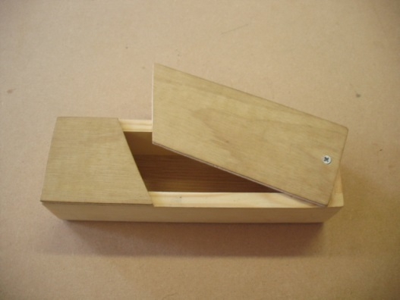
Practical work:
The pencil box

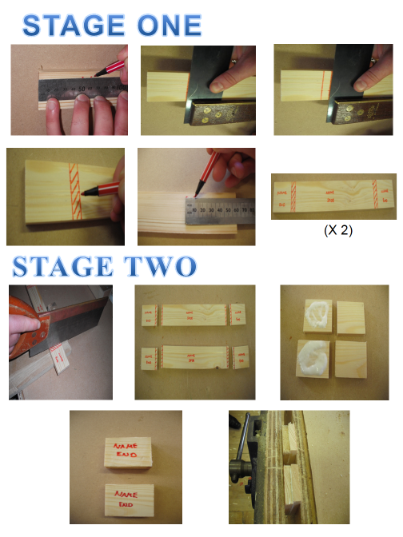

(Step by step pupil instructions and success criteria)

Key areas of Assessment:
- Safety
- Use of tools
- Marking out and measuring
- Group work
- Listening and observing

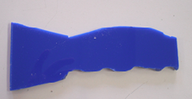
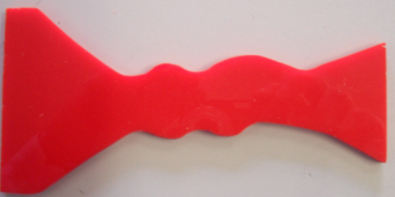
The ice-scraper
Key areas of Assessment:
- Safety
- Use of tools
- Group work
- Listening and observing

The trowel
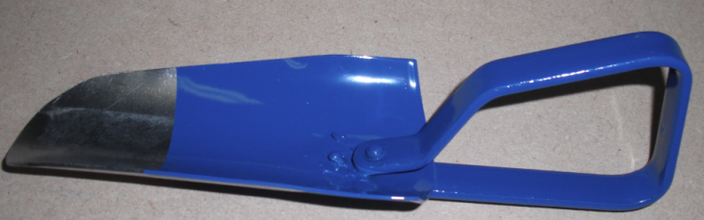
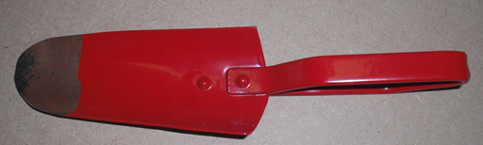

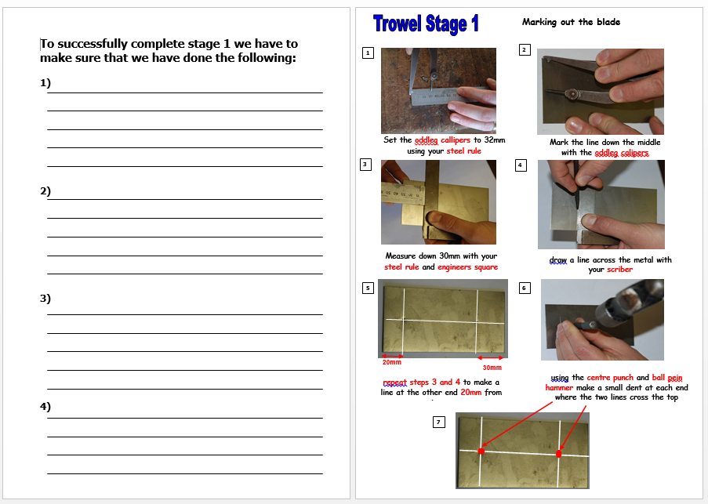
Key areas of Assessment:
- Safety
- Use of tools
- Marking out and measuring
- Group work
- Listening and observing

(Step by step pupil instructions and success criteria)

Classroom based work:
Renewables project:
Pupils are introduced to the topic of renewable energy and Scotland’s role in the generation of renewable energy. Throughout the topic, pupils will take on various roles within a group situation including; a site surveyor, a technician and a councillor. They will be given a location within Scotland and as a group they will have to determine the most suitable renewable energy source. Pupils will present their findings to the rest of the class. Pupils are actively encouraged to embrace their role.
Key areas of Assessment:
- Listening to each other within a group
- Working together within a group
- Making suggestion within a group
- Creating a presentation
- Delivering a presentation
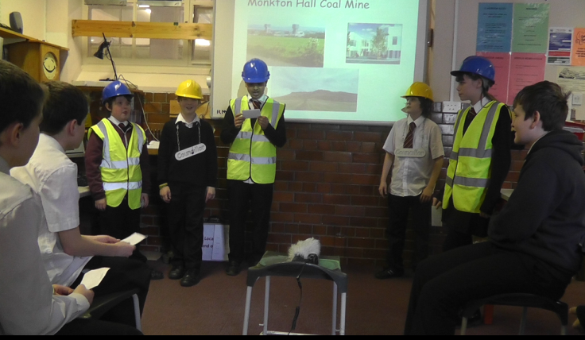
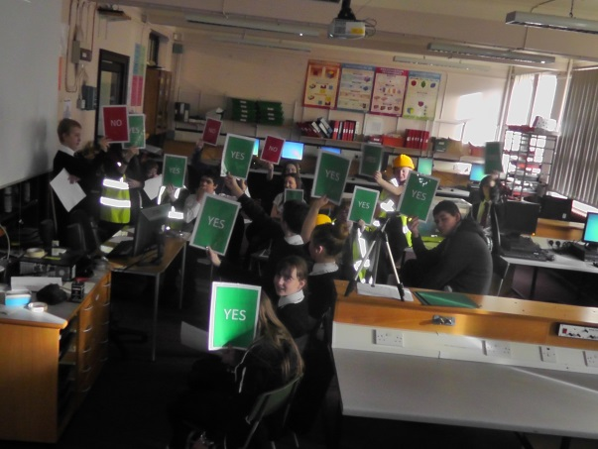

Ice-Scraper project:
Pupils are invited to work within a group to explore various design factor (materials, ergonomics, aesthetics etc) which will then be presented to the class in the form of a presentation. Once these design factors have been explored, pupils are then asked to design an ice-scraper. Pupils are introduced to card modelling and also 3D modelling. This will then be manufactured in the school workshop.
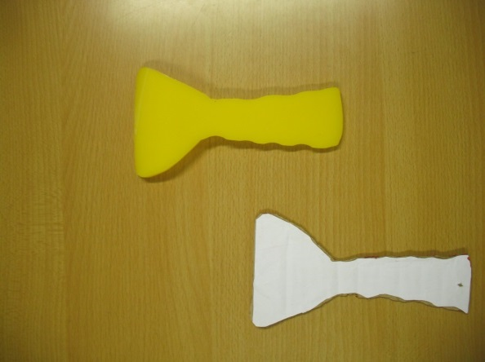
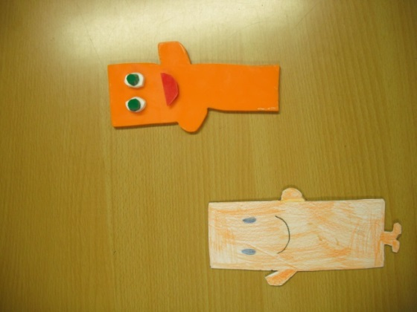

Key areas of Assessment:
- Safety
- Use of tools
- Group work
- Listening and observing

Computer game project:
Pupil’s produce their own computer game using ‘Scratch’ software. Pupils will then design a CD label and front cover for their case using a labelling package. This project is run in conjunction with the Computing department.

Key areas of assessment:
- Importing graphics
- Insert labelling and logo
- Produce text using Inventor software
- Layout

Structures project:
Pupils are introduced to the topic of structures covering; the Tay Bridge disaster, classes of structure, triangulation, compression and tension. Pupils will also use a computer software package ‘WestPoint’ to produce various bridge designs.

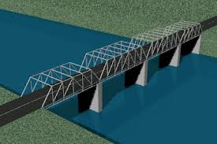

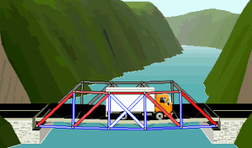

Assessment
Under the new curriculum within Technology we are aiming to make assessment pupil centred to encourage pupils to reflect on their learning. The assessment is delivered through a variety of means including; individual, peer assessment in the case of group work and some of them are teacher led assessments.
The aim of this is to identify what the pupils key strengths are at the end of a project, but more importantly, identify areas and skills that need improvement for future projects. The aim of this is to ensure continuity and real progression through the three years of a broad, general education. The aim of this is to ensure that pupils have the skills and knowledge ready to take on National 4 and National 5 courses in S4.
Below is an example of an assessment from one of our projects and the criterion the pupils use to assess their work. A further example is also shown of how the information and collated and recorded.

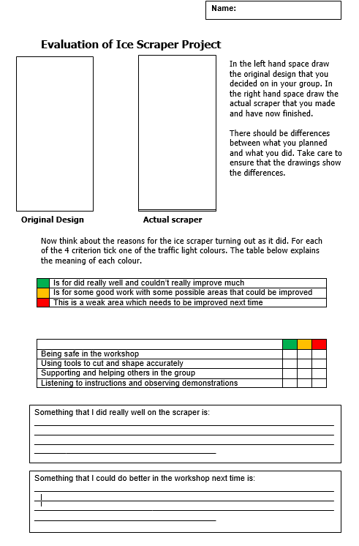
J. Bread
These are the criterion that the pupils are assessed against.

This is the box where the pupil / peer identifies something which could be improved upon.
This is the box where the pupil / peer identifies something that has been completed well
This is an example of the assessment which is carried out

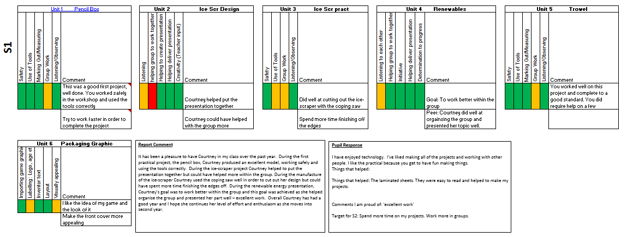
Pupil response
Pupil report comment
· Below is a copy of the comments sheet for each individual pupil.
· Each pupil is encouraged to reflect on the comments prior to embarking on their next project to help identify improvements.
At the end of the year pupils, are also asked to reflect on their work over the course of the year and respond to their report comment

