Harris Academy S2 Electives
Information Booklet

June 2023
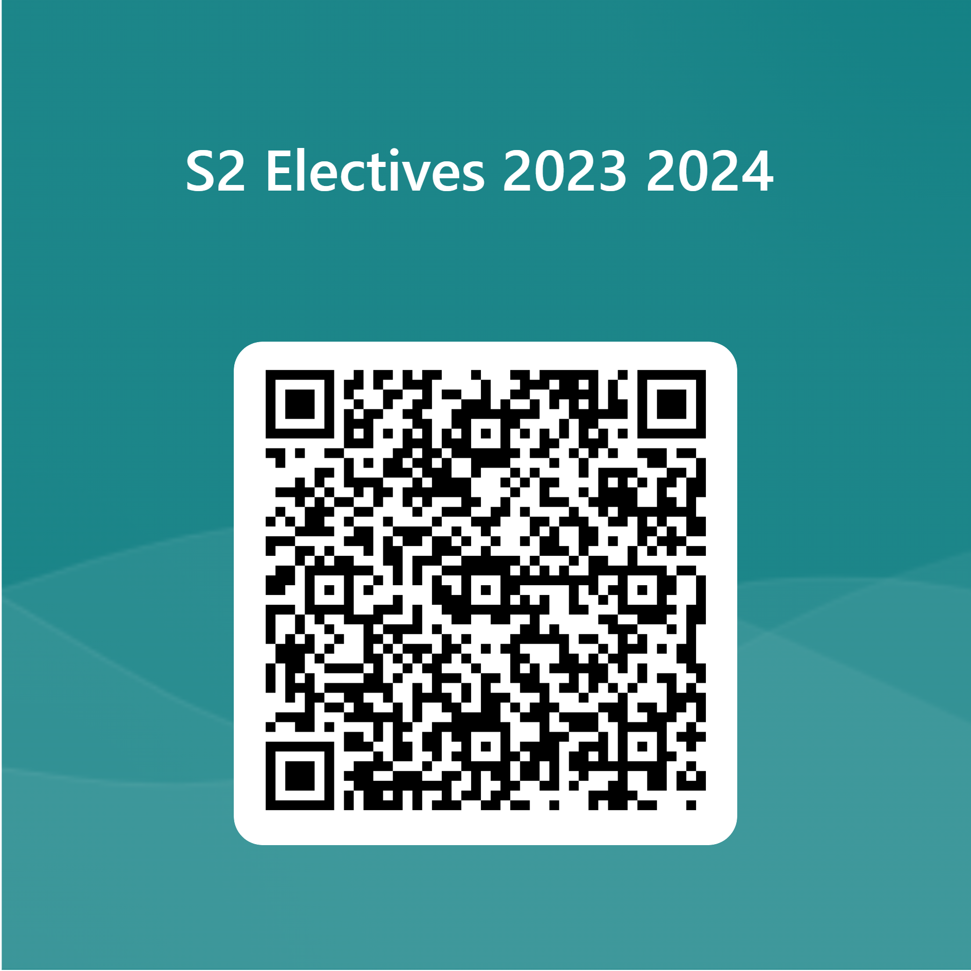

https://forms.office.com/Pages/ResponsePage.aspx?id=8ivvw5gTK0G4l47RiS-LjUC3IverUoVIhyf57vuro91UQ1NNRTNNOVhaMkQ5MjZDRjZNMTlGVU5ZUS4u

Contents
Introduction
Courses in:
Art ……………………………………….

Anime character design

Business……………………………………….
Business Enterprise

CDT…………………………………….

S2 DIY Skills

Drama…………………………………….

Hair, Make-Up, and Nails

English…………………………………
Media

Home Economics ………………………

Cake

Fashion and Textile

Foods of the World

Modern Languages……………………..

Europe through Festivals and Film

Modern Studies……………………..

Debate

Music………………………………………
Radio Broadcasting

Nurture and Inclusion………………………
Life Skills
Peer Education
Introduction
Personalisation and choice in S2
All pupils follow a Broad General Education from S1-S3, building on the progress you made in primary school and preparing you for the Senior Phase from S4-S6 when you will specialise in national qualifications. As part of your S2 curriculum you will have the chance to personalise your curriculum by choosing an extra subject known as an ‘elective’. In S2 you will study the elective you have chosen for 1 period per week for half the academic year. You will have the opportunity to study two electives in S2. Most classes will be practical sets of 20.
In this booklet you will find descriptions of all these electives. Each one is designed to provide you with extra opportunities for achievement and to build your skills for learning, life, and work.
Please read this information carefully.
Please note that all courses are subject to limitations on uptake.
This booklet is also available from the school website.
Art

- Anime Character Development

You will learn how to follow the Design process to create imaginative characters from visual research.

Business

- Business Enterprise

Entrepreneurs set up businesses for a variety of reasons. Ultimately however, successful businesses survive by meeting customer needs. Within this elective, you will be creating a business and gaining an insight into what entrepreneurs need to consider when setting up a business from scratch. You will cover topics such as customer service, marketing, human resources and finance – all of which is extremely important to be successful!

CDT

- S2 DIY Skills

We will focus on basic DIY skills that may come in useful in later life. This will be things like wiring a plug, fixing plasterboard, filling gaps in material and using basic power tools. Building on your basic workshop knowledge throughout the year we will use a variety of techniques and materials.

Drama

- Hair, Make-up, and Nails
This elective is perfect for pupils who have an interest in the hair and beauty industry. You will learn about skin, hair, and nail care as well as customer service skills with a peer taking on the role of a salon client. You will learn how to apply cosmetic products, including the tools you may use in application and how to style hair. The practical element of this course relies on pupils being able to fully participate by practising make up/ hair and nails on themselves and others.

English

- Media
How does Media influence us?

The Media class will explore ways in which media influences our daily life and the methods media creators use to impact on the choices we make. You will learn about representation and stereotypes; how characters are represented and how young people are stereotyped. You will have the opportunity to put your learning into practice by creating your own media product.

Home Economics

- Cake
In this fun elective you will bake a variety of different cake types and then decorate these using a range of cake decorating tools and decorative techniques. If you have a passion for baking and cake decorating, then this elective is perfect.

- Fashion and Textile Technology
During this elective you will become confident in the use a range of sewing tools and equipment whilst creating some fun textile projects. These range from a mini tote bag, bookmark, festive decorations and so much more. If you have an interest in learning some new textile skills or you are already a keen crafter then you will love this elective.

- Foods of the World
This elective will take you on an exciting Worldwide ‘tour’ whilst giving you a great opportunity to further develop your practical food skills. Each week you will prepare a dish from a different country, you will learn about the origins of the dishes and interesting facts about the ingredients you are using. If you enjoy cooking and are keen to expand your knowledge and skills, then this is the elective for you!

Modern Languages

- Europe through Festivals and Films
In this elective will learn about some of the fun and amazing festivals which happen around Europe. You will also have the chance to watch and evaluate films. You could even design and run your own Scottish festival taking aspects from all you learn.

Modern Studies

- Debate
Are you passionate about debating? If so, the Debate Elective is absolutely for you.
In this elective we will debate crucial social issues that are ‘hot’ topics in today’s world. Pupils will be given the opportunity to voice their thoughts and opinions on various social issues. Pupils will be given a topic to research and understand further, then given a full period to debate this topic with other members of the class.

Music

- Radio Broadcasting
An exciting opportunity to learn about recording and mixing skills whilst creating your own Radio Broadcast. You will learn how to create jingles and adverts, design and record interviews and news and weather reports, experience basic DJing skills and visit a local radio station (if restrictions allow)

Nurture & Inclusion

- Life Skills
The Inclusion Support Team would like to offer S2 and S6 pupils an opportunity to explore, develop and grow Life Skills. This will look to include budgeting and finance, independent living, moving on from school to college, university or the wider world of work. The elective would also look to discuss and learn about topics that are important to them which could include relationships, self-esteem, confidence, drugs and alcohol amongst many more. These sessions will be guided and led by the needs/interests of the young people participating in this elective.
Through these sessions senior pupils will be offered an opportunity to develop their own peer led sessions and take on leadership roles among the S2 elective cohort expanding and developing their leadership and community roles.

- Peer Education
This is a unique opportunity for selected S2 pupils to work with primary 7 pupils who will be joining us at Harris in August 2024. Initially, you will take part in a Training Programme that will help to prepare you for a series of visits to primary schools where you will be leading small groups. Ideally, we are looking for young people who can become role-models and help to inspire our future S1s. Pupils who successfully complete this elective will receive a Dynamic Youth ((Bronze) Award detailing your new skills and experiences. Please note that this elective will last all year. This is because you will spend the first half of the year undergoing the training sessions and then the second half going out to primary schools. Spaces are limited so please speak to Mrs Craven if you would like more information.

