01 February 2023

Dear Parent/Carer

S3 Parent Contact Evening - Online Booking System

I would like to invite you to attend one of our Parents’ Evenings on Tuesday 7th February at our Harris Academy building. This is an important evening and provides you with an opportunity to speak with your child’s teachers about their progress.

The forthcoming S3 Parents Evenings will make use of our online booking system and will open on the 1st of February.

Many of you may have already had experience of using the online booking system, however instructions for using the system are detailed below. The system should automatically set a default gap of 5 minutes between appointments to allow for travel time. A floorplan is also available to assist you journeying between appointments.

If you are unable to access the online system please contact the school office who will be happy to add appointments on your behalf.

Parent Instructions – Online Booking System

- Log into https://harrisacademy.schoolcloud.co.uk
- Enter your first name and surname
- Enter your child’s first name and surname and their date of birth
- Click on login & continue
- Click on ‘S3 Parent Evening’ and select appropriate date relevant to your child
  - Your child’s teachers should appear
- Click on ‘continue to book appointments’
  - You will now be able to view the available appointment times for each teacher
- Click on the time you wish to book for the first teacher. You can either leave a message or proceed to ‘add appointment’
- Repeat until all appointments are booked as necessary
- You can then print out a copy of all your appointment times for bringing on the evening.

Should you have any questions please contact the school office.

Yours sincerely

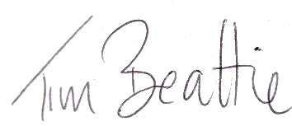

Mr T Beattie
Depute Head Teacher

