Dear Parent / Carer,
king’s Coronation holiday – school closed
Monday 8th May
s1 tracking report issued
Friday 12th May
s1 parent / carer evening
Wednesday 17th May
HT Surgery
Monday 22nd May
Dundeee & Angus college future talent (S3) event
Wednesday 24th and Thursday 25th May

Parent council meeting
Thursday 25th May
study leave ends
Thursday 25th May
INSET DAY – school closed to pupils
Friday 26th May
Victoria day holiday – school closed
Monday 29th May
new timetable begins
Tuesday 30th May

Dates for your diary

As a reminder, the school will be closed to staff and pupils this Monday for the King’s Coronation Holiday.

S6 Leavers’ Celebration

Our S6 cohort are all invited to Elliot Rd on Monday 12th June to enjoy a leavers’ event.

Year group and prefect photographs will be taken, followed by a barbeque that all staff are also invited to attend.

Saturday School and Masterclasses

Saturday School continues this Saturday the 7th of May and will run throughout the exam diet. This Saturday the focus will be English. These sessions will begin at 9am and will finish at 11am, pupils should enter through the main doors of the school and uniform is not required.

Many of our subjects are running Masterclass sessions the afternoon closest to that particular exam. Teachers leading that course will have spoken to their pupils about the session and have encouraged them to sign up. This incoming week there will be masterclass sessions for English and Health & Food Technology.

Thanks for encouraging your young people to attend these sessions. More information can be found on our study portal - https://sites.google.com/dd.glow.scot/harris-study-portal/home

Water Sports and Adventure Residential Trip
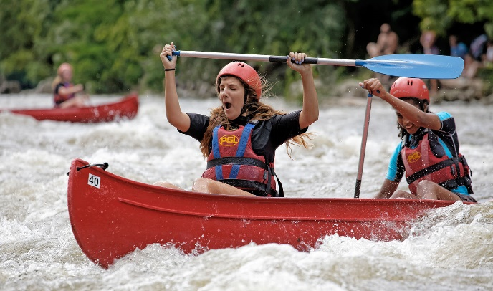
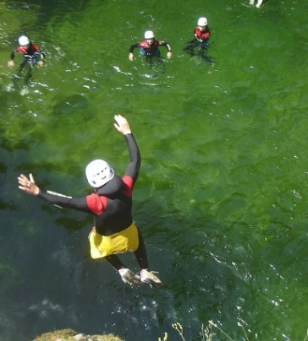
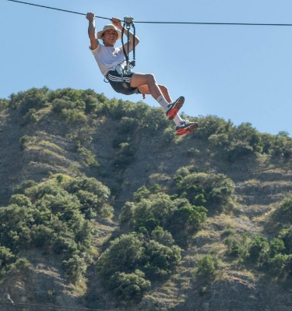
Harris Academy’s Water sports and Adventure (8-day residential trip) to the South of France
From Saturday 1st June to the Saturday 8th of June 2024

I am delighted to announce that we are heading back to the South of France in June 2024. This trip is open to the present S1, S2 and S3 pupils and will be led by Mr Harvey and organised through PGL Travel Ltd.
What does it cost?
The cost per person is £839 which can be paid in instalments prior to the trip.
The cost includes:
- Return coach/ferry travel from school
- A packed daily programme of water sports and adventure activities
- Fully supervised evening entertainment
- All meals and accommodation (excluding meals on both outward and return journeys)
- Comprehensive travel insurance
What do I need to do next?
If you would like your child to go on the trip and they have missed the information meeting, then they can find out more by contacting Mr Harvey in room 2311 (maths department)

Mr Harvey,
Maths Department

Prizegiving 2023

Our Aims and Values Award is unique in that any member of our school community (parent, partner, staff member or pupil) can win it. The recipient is awarded the trophy for exhibiting our school values on a consistent basis.

If you have any nominations for this award, please complete the short link below. The deadline for nominations is Friday 19th May.

https://forms.office.com/e/zDn2YFXfS0

Continued e-Sgoil Study Support – SQA Exams

A reminder that the national learning offer for study support will continue throughout the exam session. These study sessions are completely free and available to all our Harris S4 to S6 pupils. To see the schedule for subjects and to register please click here.

e-Sgoil have also refreshed and updated their Senior Phase learning spaces, this is a great set of resources to support during the exams and can be accessed here

Bottom corridor

The corridor that connects PE to the Tiered Seating area will be out of use from 15th May. This is to allow the extension to be connected to our main building.

Young people will be informed via Assemblies next week.

