Dear Parent / Carer,

**christmas carol service**

Monday 19th December

**Term ends**

Thursday 22nd December

**spring term begins**

Monday 9th January

**s2 tracking report issued**

w/b 9th January

**s2 parent / carer evening**

17th January

**course choice information evening (Current s3, s4 and s5) and career fayre**

Thursday 19th January

**course choice information evening (Current S2)**

Tuesday 24th January

**s4 – s6 formal assessment block**

26th January – Friday 3rd February

**Dates for your diary**

**With the end of a term approaching, I hope that you and your family have a very enjoyable festive break.**

**From all members of staff here at Harris,**

**Merry Christmas to you and your family**

**End of Term Arrangements**

**Dining Centre**

The dining centre will offer a selection of cold food for lunch at the end of the school day on Thursday, pupils are asked to come and choose for the selection of food on offer after the open mic.

It will be open at break as usual.

**Transport**

All pupil transport will be ready to leave the Perth Road at the end of the school day (12pm), once pupils are dismissed from the tiered seating, they should make their way to their bus or taxi.

**Open Mic**

**Period 1** – As normal

**Period 2** – As normal

**BGE & Senior Interval** – 10.25am – 10.40pm.

**Period 3** – Pupils go to class after interval to be registered.

**10:55am** – Pupils escorted to the Tiered Seating area by their period 3 class teacher for Open Mic event. Teachers to remain with their class to help supervise Open Mic.

**12pm** – Pupils dismissed from the Tiered Seating area through Dining Centre to exit for the holiday period.

**Non - uniform**

Thursday will be a non-uniform day for all pupils, there is no collection for this.

**S1 Outward Bound Experience** **November 2022**

A chilly and wet November did not dampen the spirits of a group of 23 S1 pupils who experienced a fantastic school trip to Loch Eil. Staying at the Outward Bound Centre, the group had great fun gorge walking, zip-lining, canoeing, orienteering, and sleeping under the stars. A huge success in developing confidence, resilience, and leadership skills in the young people. There are plans to keep the group together, and for them to become ambassadors for next year’s S1 pupils. They will become part of transition, showcasing their learning and experience to our new S1 pupils for session 2023/24.

**Rugby Trip** Mr Cunningham

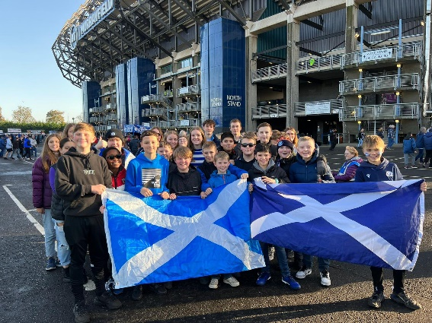

On Sunday 13th November, 32 pupils and 6 staff were fortunate enough to travel to a gloriously sunny Murrayfield Stadium, Edinburgh, to take in the Autumn Rugby International match between Scotland and the famous New Zealand All Blacks.

Although ultimately unsuccessful, it was an excellent performance by the Scotland team, with plenty Tries and closely-matched excitement for pupils to experience.

There was also the opportunity to sample all the pre-match atmosphere, both inside and out of the stadium.

The food stalls were briefly forgotten about whilst pupils watched the team piped into the stadium and, once in our seats, the singing of Flower of Scotland along with the All Blacks Haka was a real highlight. Pupils were also there to witness the late Doddie Weir presenting the match ball, an experience all the more inspirational due to his recent passing. All staff are in agreement that pupils were exemplary in their behaviour and we are all looking forward to the next opportunity to visit.

The S1/S2 Rugby Club has seen numbers increase since the trip, however there is still plenty room for more to join- especially girls. We are currently indoors, meeting at the end of the school day on a Monday. Please get in touch with Mr Cunningham if you’d like more information.

**Barista Logo Competition winners** *Mrs Nicol*

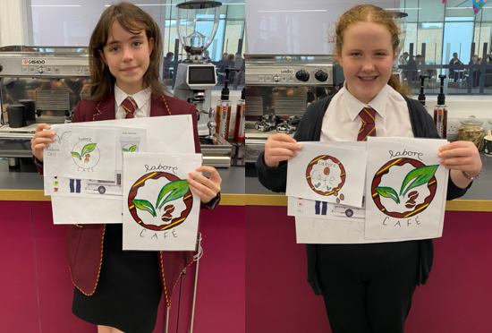*Art and Home Economics collaborated to produce branding for the school Barista area. S2 pupils were involved in designing a logo that reflects our school. Senior ‘Barista’ pupils presented the S2 pupils with prizes. Joint winners below, Caitlin Ramsay and Ailey Mathieson. Massive well done!*

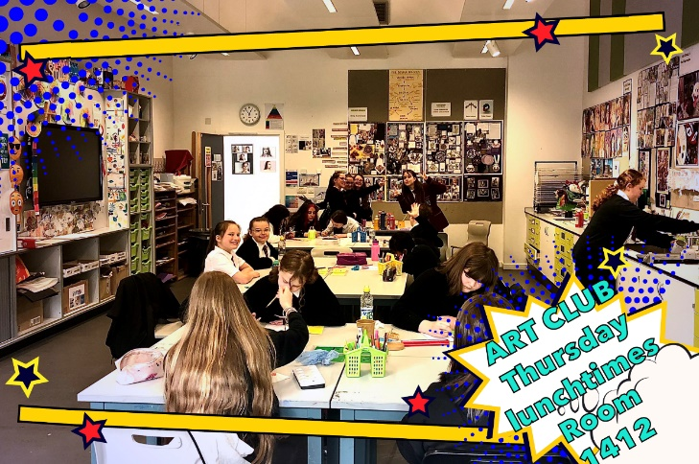**Art Club (A message from Mrs Nicoll)**

I want to thank my wonderful loyal Art Club members, all of whom have been so creative and inspiring! Living our values.

